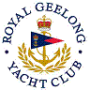 | Royal Geelong Yacht Club Inc.  Est 1859
Trophy Deed of Gift.

Trophy: | Doug Hocking Perpetual Trophy
Presented by: | Doug Hocking
Date: | 2001
For: | Open Handicap Winner of the Event so Named
Remarks / Revisions | Combined Red and Blue Division
Click here to View Recipients

